AI Lead Generation & Sales Automation
Ceramic Pro Markham
Zapier Automation Report
━━━━━━━━━━━━━━━━━━━━━━
Zapier • Gemini AI • Quo • OrbisX • Gmail

Trigger | New Lead in OrbisX CRM / Inbound Phone Call / Form Submission
Platform | Zapier
Integrations | OrbisX, Quo (SMS), Gmail, Gemini AI, Webhooks
AI Model | Google Gemini (via Zapier AI)
Output | Scored leads, personalised SMS/email follow-ups, CRM pipeline updated in real time

Project Overview

Overview
This project is a fully automated lead generation and sales system for Ceramic Pro Markham, an auto detailing business. It uses Zapier, Gemini AI, Quo, and OrbisX to capture leads from forms and phone calls, instantly respond via SMS and email, and track them through a CRM pipeline. AI analyzes call transcripts and inquiries to extract customer details, score lead quality (hot/warm/cold), and trigger personalised follow-ups. The system includes automated sequences for no-response leads, upsells, and post-booking engagement to maximise conversions. Real-time alerts ensure the team can act immediately on high-value leads. The overall goal is to automate response speed while keeping communication human-like, to increase bookings and revenue.

1 | Automation Flow — New Lead to Email / SMS

Automation Flow
1  New Lead in OrbisX | 2  Delay (Timing Control) | 3  Webhook GET (Live Data Fetch) | 4  Filter Conditions | 5  AI Analyzes & Scores Lead | 6  Quo Sends SMS | 7  OrbisX Lead Updated | 8  Gmail Sends Email

Zapier Workflow — New Lead → Email / SMS
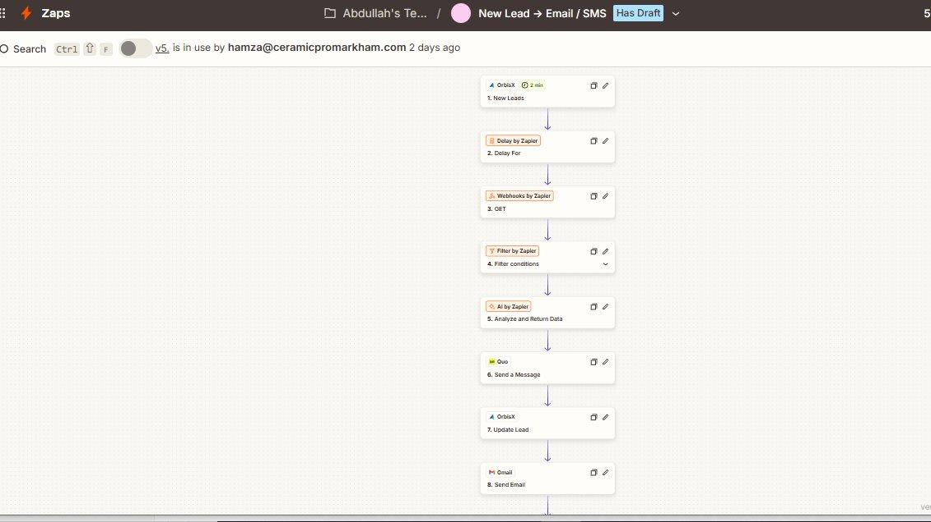
Zap 1 — New Lead to Email / SMS (Steps 1–8)



Zap 2 — New Lead to Email / SMS (Continued)

2 | How It Works — Step by Step

- Step 1 — New Lead Detected: OrbisX CRM detects a new lead record — sourced from a website form submission or inbound phone call — and triggers the Zapier workflow.
- Step 2 — Delay (Timing Control): A Zapier Delay step holds the workflow briefly before proceeding, giving the CRM time to fully populate the lead record and avoiding premature data fetches.
- Step 3 — Webhook GET (Live Data Fetch): A Webhooks by Zapier GET call fetches the current, fully-populated lead data directly from OrbisX in real time, ensuring the most accurate details are used in all subsequent steps.
- Step 4 — Filter Conditions: Conditional logic checks whether the lead meets the criteria to proceed (e.g., not already contacted, valid phone/email present). Leads that do not pass are halted here to prevent duplicate outreach.
- Step 5 — AI Analyzes & Scores Lead: Gemini AI (via Zapier AI) reads the lead's inquiry text and/or call transcript, extracts key customer details (vehicle type, service interest, budget signals), and assigns a lead score: Hot, Warm, or Cold.
- Step 6 — Quo Sends SMS: A personalised SMS is sent to the lead via Quo within minutes of capture. Message content is tailored based on the AI-extracted details and lead score.
- Step 7 — OrbisX Lead Updated: The lead record in OrbisX is updated with the AI-generated score, extracted customer details, and the current outreach status — keeping the CRM pipeline accurate.
- Step 8 — Gmail Sends Email: A follow-up email is sent via Gmail with service information, pricing context, and a call-to-action to book an appointment — personalised based on the lead's detected interests.
3 | AI Lead Scoring — Hot / Warm / Cold

Gemini AI analyzes each lead's inquiry content and assigns one of three scores that determines the urgency and type of follow-up triggered:

Score | Criteria
🔥 Hot | High-value service interest, detailed inquiry, quick response to initial contact
🟡 Warm | General interest, moderate service value, some engagement but not yet committed
🔵 Cold | Vague inquiry, low-value service, no response to initial follow-up attempts

Hot leads additionally trigger a real-time internal team alert, ensuring a human team member can follow up manually and personally for maximum conversion probability.

4 | Automated Follow-Up Sequences

Sequence | Description
Immediate Response | SMS sent within 2 minutes of lead capture via Quo
No-Response Follow-Up | Automated sequence re-engages leads that do not reply within defined window
Upsell Sequence | Post-booking messages promote ceramic coating upgrades and add-on services
Post-Booking Engagement | Confirmation, preparation tips, and review request after service completion
Hot Lead Alert | Real-time team notification triggered for high-scoring leads requiring manual outreach

5 | Challenges & How the Workflow Addresses Them

- Leads go cold quickly in the auto detailing market — speed of response is critical: The workflow fires immediately on lead capture and sends an SMS within minutes via Quo, ensuring Ceramic Pro Markham is the first to respond — a key factor in winning bookings against competitors.
- Call transcripts and form submissions contain unstructured text — extracting useful data is unreliable with rules: Gemini AI is used to read the raw inquiry or transcript and extract structured fields (vehicle type, service, budget signals) and a lead score, replacing fragile keyword matching with intelligent natural language understanding.
- Not all leads are equal — treating every inquiry the same wastes team time: The AI scoring system (Hot/Warm/Cold) ensures the team focuses manual effort on high-value leads while lower-priority leads are handled entirely through automated sequences without human involvement.
- Leads that do not respond need to be re-engaged without manual tracking: Automated no-response sequences re-engage cold or unresponsive leads on a timed schedule, sending additional SMS and email touchpoints until a response is received or the sequence expires.
- Data in OrbisX may not be fully populated at the moment the trigger fires: A Delay step followed by a live Webhook GET ensures the workflow always reads the fully-populated lead record rather than acting on incomplete data from the initial trigger payload.

6 | Tools & Integrations

Tool / Service | Role in Workflow
OrbisX CRM | Auto detailing CRM — source of new leads and pipeline stage management
Zapier | Core automation engine — orchestrates all Zap workflows and step logic
Zapier AI (Gemini) | Analyzes call transcripts and inquiry text to score leads and extract customer details
Quo | SMS messaging platform — sends personalised text messages to leads
Gmail | Email delivery — sends follow-up and confirmation emails to leads
Webhooks by Zapier | Fetches live lead data mid-workflow to verify current status before actioning
Filter by Zapier | Conditional logic — ensures only eligible leads proceed through the workflow
Delay by Zapier | Timed pauses — controls follow-up timing and sequence intervals

System Architecture Summary

INPUT SOURCES | ZAPIER AUTOMATION | OUTPUT
• Website Form Submissions  • Inbound Phone Calls  • OrbisX New Lead Records | • Gemini AI Lead Scoring  • Delay & Filter Logic  • SMS via Quo  • Email via Gmail  • CRM Pipeline Updates | • Instant SMS Follow-Up  • Personalised Email Sent  • Lead Scored in OrbisX  • Hot Lead Team Alert  • Automated Re-Engagement

End of Document

